Order Of Service

Singing: Psalm 47—CW page 85

Reading: Psalm 145

Opening Hymn: TLH 367

Reading: I Corinthians 1:26-31

Request Hymn: CW Supplement 749

Reading: Matthew 25:14-30

Sermon Hymn: TLH 342

Sermon Text: Luke 7:36-50

Two Sinners

Prayer

The Apostles’ Creed, TLH page 12

Holy Communion

The Lord's Prayer

The Blessing

Closing Hymn: TLH 436

* * * * * * * * * * *

Bible Study: Lambs: Common Flea
Sheep: Proverbs 30:21-28
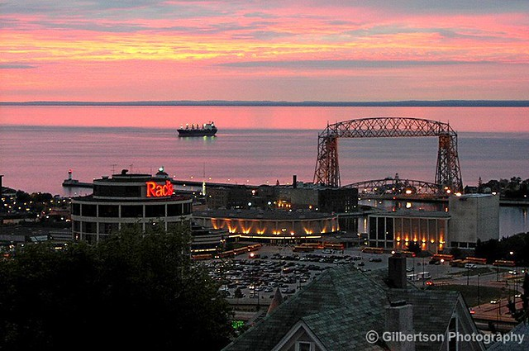

The Zenith City

Water
Of
Life

27 June 2021

W A T E R O F L I F E

Independent Christian Church—Conservative Lutheran Doctrine

Worship Service: 9:30 a.m. Bible Study: 10:45 a.m.

Larry Cooper, Pastor E-Mail address:
111 N. Ridge Road lcooper@wateroflife.cc
Coon Valley, WI 54623 Web Site:
www.wateroflife.cc

* * * * * * * * * * * * * * * * * * * * * * * * * * *

Sermon Text: Luke 7:36-50

Two Sinners

* * * * * * * * * * * * * * * * * * * * * * * * * * *

Luke 7:36 And one of the Pharisees desired him that he would eat with him. And he went into the Pharisee's house, and sat down to meat.
:37 And, behold, a woman in the city, which was a sinner, when she knew that Jesus sat at meat in the Pharisee's house, brought an alabaster box of ointment,
:38 And stood at his feet behind him weeping, and began to wash his feet with tears, and did wipe them with the hairs of her head, and kissed his feet, and anointed them with the ointment.
:39 Now when the Pharisee which had bidden him saw it, he spake within himself, saying, This man, if he were a prophet, would have known who and what manner of woman this is that toucheth him: for she is a sinner.
:40 And Jesus answering said unto him, Simon, I have somewhat to say unto thee. And he saith, Master, say on.
:41 There was a certain creditor which had two debtors: the one owed five hundred pence, and the other fifty.
:42 And when they had nothing to pay, he frankly forgave them both. Tell me therefore, which of them will love him most?
:43 Simon answered and said, I suppose that he, to whom he forgave most. And he said unto him, Thou hast rightly judged.
:44 And he turned to the woman, and said unto Simon, Seest thou this woman? I entered into thine house, thou gavest me no water for my feet: but she hath washed my feet with tears, and wiped them with the hairs of her head.
:45 Thou gavest me no kiss: but this woman since the time I came in hath not ceased to kiss my feet.
:46 My head with oil thou didst not anoint: but this woman hath anointed my feet with ointment.
:47 Wherefore I say unto thee, Her sins, which are many, are forgiven; for she loved much: but to whom little is forgiven, the same loveth little.
:48 And he said unto her, Thy sins are forgiven.
:49 And they that sat at meat with him began to say within themselves, Who is this that forgiveth sins also?
:50 And he said to the woman, Thy faith hath saved thee; go in peace.

